

**INSTANT ELECTRONICS SERVICE**

A Non-Syllabus Project Report

**Bachelor of Technical**

**I Year**

By

**Kushal Mittal Reg No. : PCE22AD033**

**Lakshya Khandelwal Reg No. : PCE22AD034**

**Mohit Kumar Singh Reg No. : PCE22AD037**

**Krishna Soni Reg No. : PCE22AD032**

**Kartik Sharma Reg No. : PCE22AD030**

**Under the guidance of**

**Mrs. Deepika Agarwal - Assistant Professor**



(Session 2022-23 , ODD Semester)

**Poornima College of Engineering**

ISI-6, RIICO Institutional Area , Sitapura , Jaipur-302022

**February, 2022**

**INDEX**

1. **INTRODUCTION……………………………………………………**

**2. OBJECTIVES.………………………………………………………..**

*2.i. Problem Description*

1. **METHODOLOGY…………………………………………………...**
2. **HARDWARE SOFTWARE USED /**

**TOOLS AND TECHNIQUES……………………………………….**

1. **EXPERIMENTAL RESULTS………………………………………**

*5.i. Coding and Algorithm used*

*5.ii. Output*

1. **FUTURE WORK…………………………………………………….**
2. **CONCLUSION……………………………………………………….**
3. **REFERENCES……………………………………………………….**
4. **INTRODUCTION :**

Instant Electronic Services (IES) is basically a website which can be used as connecting link between costumer and electrician .

First of all , there is the home page of the website which contains some of the pictures of Electronic Gadgets, when we click on IES Service we can see the availability and prices of services that we provide are mentioned from where we can select different possibilities for different services .

For the user to choose the desired service he/she can book services are given on IES Services , so that they can contact and ask for further details about their desired services.

In this project , we spent a lot of time acquiring the information related to almost all the possible private electronic services nearby us so that we can provide cheap , affordable and desired services for the users .

1. **OBJECTIVES :**

The project is about the instant electronic services, this is a simple html page and the main objectives of the project is to make it easier to use private instant electronic services for the people near our college area under 50 km , who do not have much idea about the availability of electronic services near college so that it is easier for them to reduce travel time between there our home and electrician .

Many services are available near our college but people used to choose to do that work by self instead of calling electrician or plumber just for saving money as we call them personally they make a lots of trouble which are really problematic for older peoples , as the customer by the help of this project will easy their work of calling some mechanic for their required service which are available in our particular area , as a result this will reduce the travel time and easier to find the mechanic for their service.

We have mentioned the private service regarding household appliances(electrical and plumbing) because it is almost impossible to get a cheap and good service provider.

**Some short key points of the objectives are as Follows:**

i. Make it easier for the people to use private household appliances(electrical and plumbing) services.

ii. Use of different kind of services available in a particular area .

iii. Use of private services and to save money of common people.

iv. To help people finding the proper mechanic regarding their need

***2.i. Problem Description :***

This project is about providing services for people who want those services, So , that they don’t have inconvenience by looking at different places or asking for different services .They have to ask from a third person for a suitable service they have needed , some people feel shy to ask from any other person.

Nowadays everyone has mobile phone and internet connection so in this situation if a person would have such a website where they can easily search for any suitable service and get to know about the services they will be getting, they do not have to ask from anyone and can search it by their own.

**3. METHODOLOGY**

The Project is about Instant Electronic Services in Jaipur in our particular area which help the citizens to easily find out the available services in our specified area. So for developing this project we followed a sequential method which makes the project easier for us to develop.

First of all , we have done qualitative research and then gathered the data of all the possible services and their prices that we have mentioned in our project and then analyse all the collected data.

We have collected the data by personally visiting to many private services .We have analysed the collected data by travelling some of the area and then conclude to proceed in the project that we have chosen.

At last we have tested whether the whole project is in working condition or not and only after getting assured of that project is working we have submitted it.

**A flowchart of sequence that we have followed during our project is :**

**1. Collection of Data**

**2. Data analysis**

**3. Writing the code**

**4. Testing the project**

1. **HARDWARE AND SOFTWARE USED/TOOLS AND TECHNIQUES :**

RAM : 4 GB (Minimum)

8 GB (Recommended)

Operating System : 32 bit x86 (Minimum)

64 bit x64 (Recommended)

Hard disk : Minimum 250 MB Free Memory

Processor : Dual Core 2.80 GHz or Higher

Screen Resolution : 1366 x 768 (Optimal)

Graphics Card : Minimum 1 GB

Platform : Windows 8/10/11 with SP1

For the development of this project we needed a source code editor so we have used VS-code this purpose and we also needed a browser to run or check every time when we do any change in our project so we have used chrome browser.

***Tools and Techniques :***

We have developed this project on windows by using many programming languages like **HTML and CSS.** And to program this whole project we needed a source code editor on which we can write our codes so we have used Sublime Code for this purpose.

For the technique we used in this project , we have first gathered all the necessary details that are required for our project and then proceed for it and completed all the related programming :

**Hyper Text Markup Language** (HTML) provides a means to create structured documents by denoting structural semantics for text such as headings, paragraphs, lists, links, quotes and other items. So we used the HTML to create the pages of our website.

**Cascading Style Sheets** (CSS) is a stylesheet language used to describe the presentation of a document written in HTML. CSS describes how elements should be rendered on screen. On paper, in speech, or on other media. We have used the CSS to make our pages look attractive by adding colours and images.

**5. EXPERIMENTAL RESULTS :**

**5.i.  *CODING AND ALOGORITHIMS USED :***

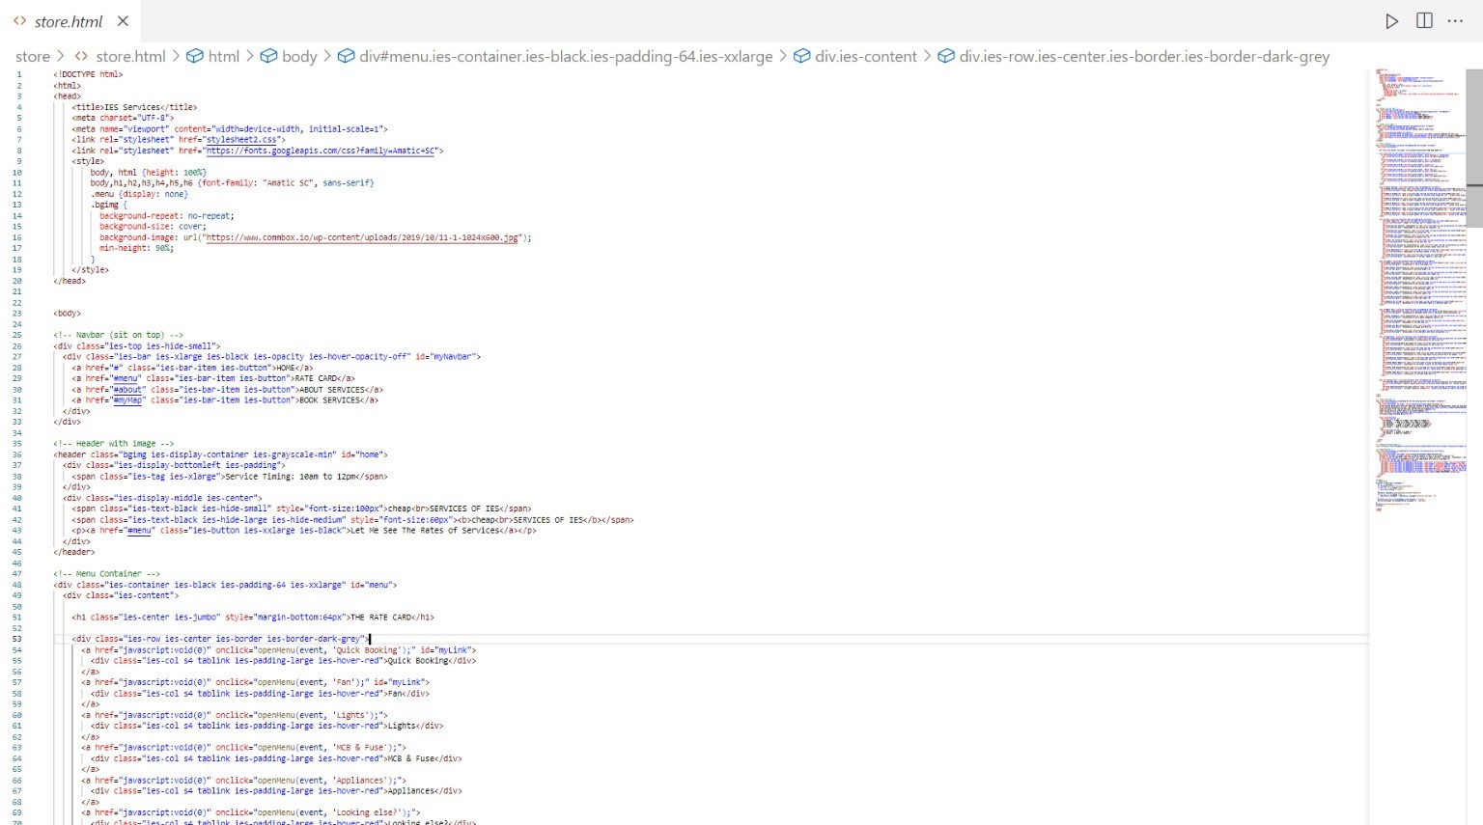

***5.ii. OUTPUT :***



**6. FUTURE WORK**

As for now the project is not a real website or we can say a working website it is just a webpage created using HTML, CSS . So, if we talk about the future work of our project then it can be developed into a working website. We can get the domain of our website in future if users find it useful in their daily routine life.

We have just created a simple algorithm of our idea that how our project is going to work according to the needs of the users.

Launching our website on proper platform after further upgradations and improvements . Merging of various types of data from other sites to make our website more effective , informative and productive for our users .

**7. CONCLUSION**

The project is about the electronic and plumbing services in Jaipur in our particular area and the main aim of the project is to making it easier for the people to search for services at their desired expenses.

By the time of development of this project we came to know about many new things like we came to know that there are many household services are available near our college area at a very cheap price.

We have learnt many programming languages for developing this project like HTML and CSS which will be helpful in our whole life as a student of Computer Science.

We have learnt that how to work as a team that will definitely help in our future projects and also help in future when we will be working for a company or even for ourself.

**8. REFERENCES :**

***Websites***

* [www.youtube.com](http://www.youtube.com)
* [www.w3schools.com](http://www.w3schools.com)
* [www.getboostrap.com](http://www.getboostrap.com)

***Pesrons***

* **Mrs. Deepika Agarwal - Assistant Professor Computer Science**
* **Mr. Anirudh Sharma - Teacher Assistant (4th Year, PCE , Jaipur)**
* **Private rental service owners near our college**